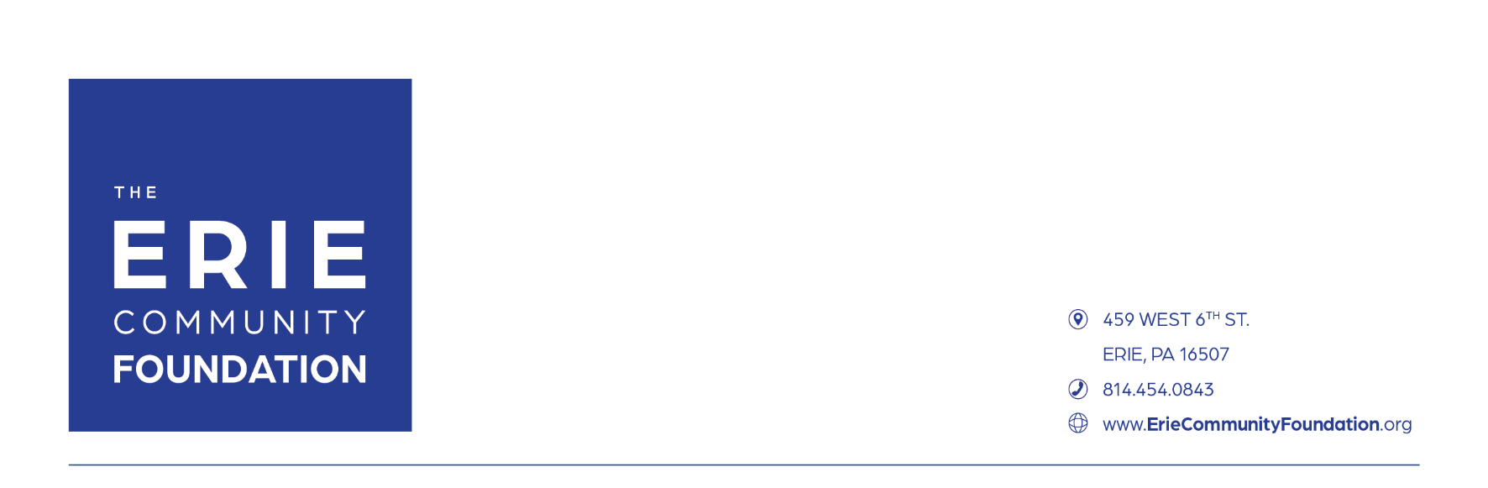

**Marketing and Communications Internship Program**

1. **Position Summary:**

The Erie Community Foundation’s mission is to inspire, engage, and empower donors and communities across the region, today and tomorrow. We envision a united, vibrant, and thriving region for all. The Erie Community Foundation is a collection of over 900 charitable funds operating under the administrative umbrella of a single public charity.

The Marketing and Communications Intern works directly with the Marketing & Communications team. Interns will have the opportunity to work with all the teams of The Erie Community Foundation, especially the Community Impact Team and the Philanthropic Services team to learn about grantmaking and donor stories. Interns will learn about managing two of the Foundation's signature events: the Annual Meeting (June 12, 2025) and the 15th Annual Erie Gives (August 12, 2025).

The Mar/Comm intern will observe and participate in press conferences and special events; understand how public relations work throughout the year with strategic goals, and gain insight into the correlation of public relations and donor relations. Interns will have opportunities to meet and interact with various community leaders, especially those in the nonprofit sector. Interns are encouraged to build a portfolio of projects completed by showcasing samples of work.

Upon completion of the internship, the successful candidate will gain valuable work experience outside the classroom and hone professional skills needed for a career in marketing, communications, or public relations.

1. **Primary responsibilities include, but are not limited to:**

The Marketing & Communications team is responsible for all internal and external communications as well as Foundation-wide marketing efforts. Our Interns will support the execution of marketing plans for Foundation activities including:

* Assisting with events including
  + The Erie Community Foundation’s annual meeting
  + Erie Gives
  + Press Conferences
  + Affinity Fund events and possibly Affiliate Foundations events
* Creating content and updating the Foundation’s social media including:
  + The Erie Community Foundation website
  + Facebook, Instagram, LinkedIn
* Creating content and updating the Affinity Fund’s social media including:
  + Their respective websites
  + Facebook & Instagram
* Contributing to and writing articles for
  + E-newsletters – every other month, at minimum
  + Website – varies from 1-4 stories a month
* Designing various marketing materials.
* Assisting with various projects throughout the organization which may include making brochures, setting up events and meetings and other miscellaneous administrative needs.
* Understanding the public relations strategic plan and big picture agenda of the Foundation.

1. **Qualifications**

* Rising college senior; Rising juniors are welcome to apply; however, preference will be given to rising seniors
* Major in Marketing, Communications, Graphic Design, Hospitality/ Event Management, Public Relations, or a related field
* Proficiency in Microsoft Office to include Word, Excel, PowerPoint, and Outlook and Canva

1. **Position Dimensions**

* **Schedule:**
  + The Erie Community Foundation is open Monday – Friday 8:30 a.m. until 4:30 p.m. A majority of the internship will fall between these hours. However, there are a few instances when the Marketing and Communications Intern will be asked to work beyond these hours such as on Erie Gives (Tuesday, August 12th, 2025) and The Foundation’s annual meeting (Thursday, June 12, 2025). Advance notice will be given for such occasions.
  + The summer internship would ideally begin in May and run through August, with an opportunity to stay on longer.
* **Wage:**
  + Hourly wage of $15
  + Interns are eligible to collect credits with your college/university as part of this internship.
  + As an intern, you will receive “temporary employment” status and would not be eligible for employee benefits available to regular Foundation employees, including health insurance, vacation, and sick pay, paid holidays, and participation in the Foundation’s 401(k) plan.
* **Application details:**
  + Please email your resume and cover letter to Kailey Pisani, Marketing & Communications Associate, at [KPisani@ErieCommunityFoundation.org](mailto:KPisani@ErieCommunityFoundation.org) by **February 21, 2025**.
  + Interviews will begin **Monday, March 8, 2025.**